**Week 5**

**Weekly learning**

* MVVM
* Data Binding

1. Property binding
2. Collection binding
3. Command binding

* Adding a listview

**Assignment progress (Week 5)**

* “Configure shortcut” but has been connected to the third and final screen
* Third screen has been created and coded
* All bugs have been tackled
* Project is running smoothly
* Application demonstration has been done and will be uploaded with final project

**Updated GitHub up until week 5**

[**https://github.com/usmankquddusi/SIT313_Project1**](https://github.com/usmankquddusi/SIT313_Project1)

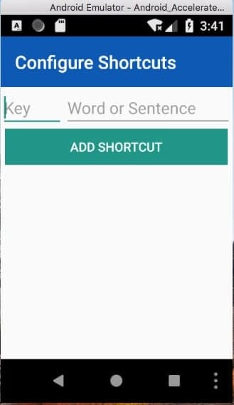

*Third screen*

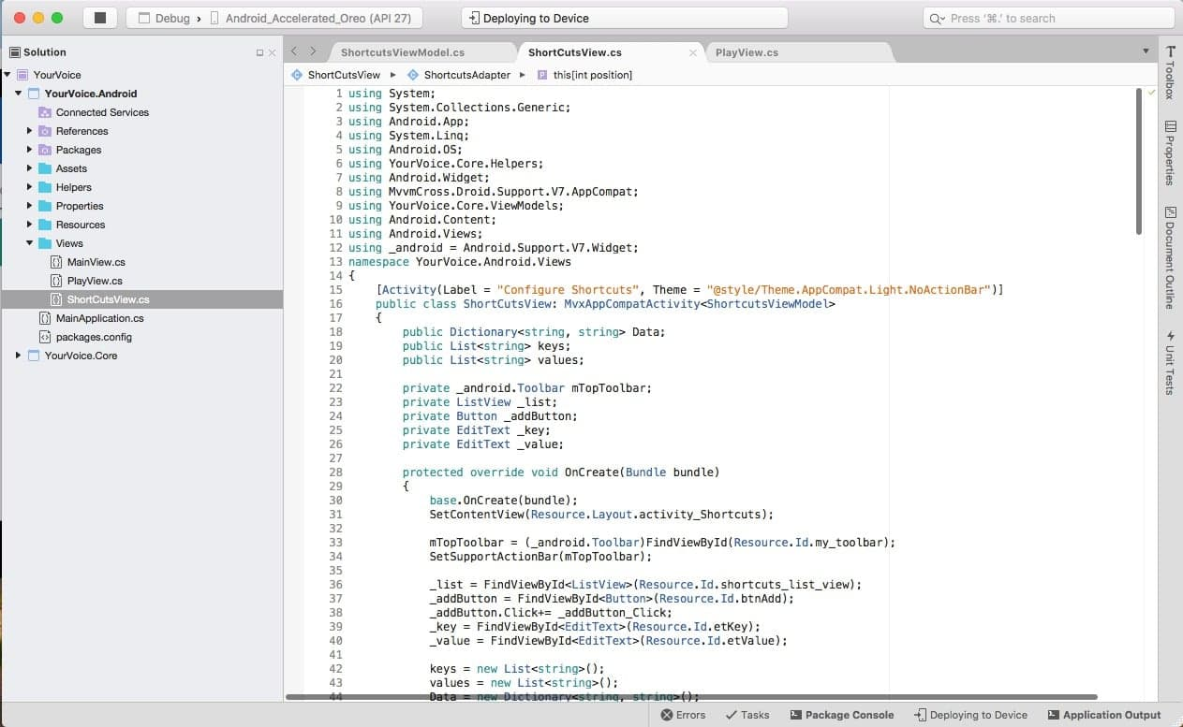

Third screen code